Introduction:
The crusades were a series of religious wars fought by the Christian kingdoms against the Muslim kingdoms to recover the Christian Holy land. The First Crusade was the first wave of christian followers towards the Levant to suppress the Seljuk Turks and the Islamic faith in the region, in an effort to reclaim their religious Holy Land following Pope Urban II’s declaration at the council of Clermont in 1095.

Background information:

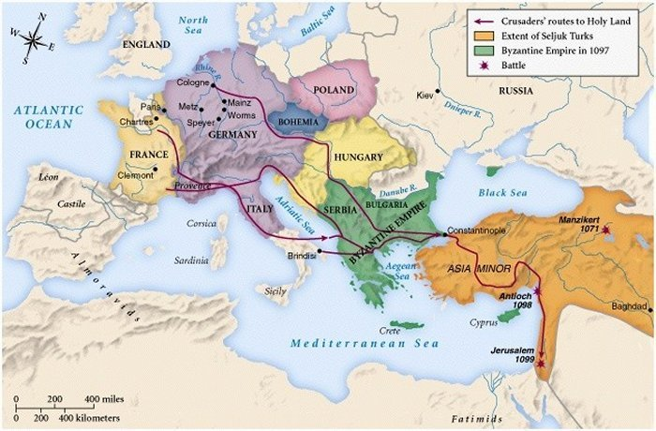

Historically, the land of the Levant though specifically Israel, holds incredible religious significance to those of Christian faith because of the areas association with the birth, ministry, crucifixion and resurrection of Jesus Christ. According to Biblical teachings, Jesus was born in Bethlehem, raised in the City of Jerusalem, held a childhood home in Nazareth, had his last supper in the Cenacle and was crucified at the Golgotha; making Israel the centre of the Christian faith and an undisputed sacred place.

Since 63 BC, the Roman Empire controlled the region of Judah (wider Israel) as an administration of the Roman province of Syria following general Pompey’s eastern campaign. Then, with the collapse of the Roman Empire and the subsequent creation of the Byzantine empire (the continuation of the Roman Empire in its eastern provinces during Late Antiquity and the Middle Ages, when its capital city was Constantinople) , Israel, Judah and the holy land became apart of the Byzantine Empire in 330 AD, until 614 AD when they lost control of the city to the Sasanian empire (the last kingdom of the Persian Empire before the rise of Islam. Named after the House of Sasan, it ruled from 224 to 651 AD) which had spread West from Persia. Sasanian rule was short-lived and the Byzantines took back control in AD 629.

At the same time in the 7th century, it is said the angel Gabriel appeared to an Arabian, Muhammad and told him to recite the word of Allah (God). The Prophet Muhammad, a member of the Arab Quraysh tribe (a mercantile Arab tribe that historically inhabited and controlled Mecca and its Ka'aba), as such founded a new religion called Islam. His Muslim followers quickly expanded throughout Arabia and the surrounding area to spread the monotheism of Islam and convert the Middle Eastern populations. In 621 AD, during the Isra’, Muhammad traveled on the steed Buraq to “the farthest mosque”, later identified as the Al-Aqsa Mosque in Jerusalem. Here, he led other prophets in prayer and then ascended to the heavens in the Mi’raj (The Isra and Mi'raj are the two parts of a Night Journey that, according to Islam, Muhammad took during a single night around the year 621 CE. It has been described as both a physical and spiritual journey) - making Jerusalem a site of religious significance to Muslims.

In November of 636, after Muhammad died, the second caliph (a caliphate is an Islamic state under the leadership of an Islamic steward with the title of caliph, a person considered a religious successor to the Islamic prophet Muhammad and a leader of the entire ummah ) Umar ibn Al-Khattab assumed control over the Rashidun Caliphate (the Rashidun Caliphatewas the first of the four major caliphates established after the death of the Islamic prophet, Muhammad. It was ruled by the first four successive caliphs (successors) of Muhammad after his death) , and the Islamic empire concentrated their eyes on the holy land of the Levant. Following Byzantine defeat at the battle of Yarmouk (a major battle between the army of the Byzantine Empire and the Muslim forces of the Rashidun Caliphate.) , the islamic empire went on to besiege the city of Jerusalem and after a six month war, the Byzantine Patriarch Sophronius agreed to surrender and submit to the Caliph. For the next 400 years, the lands were ruled by various muslim caliphs until 1077 when the Seljuk Turks (a medieval Turko-Persian Sunni Muslim empire, originating from the Qiniq branch of Oghuz Turks. The Seljuk Empire controlled a vast area stretching from the Hindu Kush to western Anatolia and the Levant, and from Central Asia to the Persian Gulf) took over from the Fatimids (The Fatimid Caliphate was a Shia Islamic caliphate that spanned a large area of North Africa, from the Red Sea in the east to the Atlantic Ocean in the west. The dynasty of Arab origin ruled across the Mediterranean coast of Africa and ultimately made Egypt the centre of the caliphate) .

Further North, the Seljuk Turks continued their conquest of expansion into Asia minor (AKA Anatolia, the westernmost protrusion of Asia, which makes up the majority of modern-day Turkey.) , pushing the Byzantine’s back further and further with the battle of Manzikert (The Battle of Manzikert was fought between the Byzantine Empire and the Seljuk Empire on 26 August 1071 near Manzikert, theme of Iberia.) , and later occupation of Nicaea ( an ancient city in northwestern Anatolia, primarily known as the site of the First and Second Councils of Nicaea ) and parts of Anatolia. Alexius I Comnenus took the Byzantine throne in 1081 and continued to resist Seljuk imperialism, which proved difficult as the few remaining Byzantine cities in Asia minor were lost.

Consequently, in 1093 Alexius wrote to Robert, Count of Flanders (Ruler or sub-ruler of the county of Flanders, beginning in the 9th century. ), appealing to him to help save the Byzantine Empire and its church from Seljuk Turks by asking for weapons, supplies and skilled troops. Pope Urban II also read the letter and in 1095 convened both the secular and ecclesiastical Christian figures of Europe, where he delivered a speech, encouraging devout christians to launch a crusade to retake the holy land from the Seljuk Turks.

Although Muslims had occupied the Holy Land for over 400 years, the reason Pope Urban the II was now concerned about the occupation was, in addition to saving the Byzantine Empire, for personal gain.

In order to raise a large army, the Pope offered absolution for all previous sins if the soldiers fought in the Crusade. In the extremely faith driven society that was Medival Europe, this worked.

Peter the Hermit, a priest from the city of Amiens, proclaimed the famous words “Deus Vult!”, meaning “God wills it”, and people start enlisting in the People’s Crusade.

The People’s Crusade was made of of 3 splinter groups of poorly equipped and trained peasants who went before the planned “actual” crusade (The Princes’ Crusade) conducted by the well trained Knights. On their way to the Holy Land they looted, pillaged and massacred territories, including the very ones they were supposed to be fighting for. The group was eventually surrounded by the Turkish forces and easily eliminated by the well trained troops.

If you would like to know more about the People’s Crusade, although it is not necessary, the first two episodes of this Youtube Series are very comprehensive.

The Princes’ Crusade started as 5 separate forces that rendezvoused at Constantinople and from there they sailed across the Bosphorus as one unit. They then arrived at Anatolia. It is here we begin the Crusades.

The details of troop numbers, weapons, resources, maps etc will be provided in your portfolios. They will each have a section specific to each cabinet. Hence only the fellow members of the cabinet know the true capabilities of their army.

Timeline of events:

The events leading to the Crusades:
- 637 CE: Caliph Umar the Great conquers Jerusalem from the Christian Patriarch.
- 1009 CE: Fatimid Caliph al-Hakim orders the destruction of all churches and synagogues
- 1030 CE: Caliph Ali az-Zahir signs a treaty with Romanos III Argyros, which authorizes the rebuilding of Christian churches in the caliphate
- 1042 CE: Constantine IX Monomachos pays for the restoration of Christian churches, most notably the Church of the Holy Sepulchre, under the authorization of Caliph Ma’ad al-Mustansir Billah
- 1054 CE: The Great Schism, a split between the Eastern Orthodox Church and the Catholic Church.
- 1073 CE: The Great Seljuk Empire conquers Jerusalem under Atsiz ibn Uvaq
- 1077 CE: Jerusalem revolts against the rule of Malik-Shah I’s Great Seljuk Empire, which leads Atsiz ibn Uvaq to massacre the population of Jerusalem.
- 1077 CE: Governor of Syria, Tutush I, executes Atsiz, and appoints Artuq bin Ekseb as governer.
The immediate events leading to the Crusades:
- 1095 CE: Emperor Alexius I sent word to Pope Urban II about the murders of over 3,000 Christians in Jerusalem, which took place between 1085 and 1095 CE, among other atrocities. Along with this, Emperor Alexius I noted the growing threat of Turks in Europe.
- 1095 CE: Pope Urban II gives a speech at the council of Clermont, calling for a crusade to take back the Holy Land from Muslim invaders.
- 1095 CE: Peter the Hermit, a priest from the city of Amiens, proclaimed the famous words “Deus Vult!”, meaning “God wills it”, and people start enlisting in the People’s Crusade.
- 1096 CE: Emperor Alexius I sent the People’s crusade to Bosphorus, Turkey, where they were defeated by the Turks.
The Start of the Princes’ Crusades:
- 1096 CE: The First Crusade started at Constantinople, led by Tancred and Godfrey of Bouillon, to name a few.
- 1097 CE: The Crusaders land at Anatolia and it is from this point that we begin the war.

After the war:
The first crusade formed Crusader States of Edessa, Jerusalem, Tripoli, Antioch in Palestine and Syria that were ruled by the leaders of the Crusade. Godfrey ruled for a year before passing away in 1100. Many of the crusaders went back home. The Crusaders who reached Jerusalem were treated with respect. Robert Curthose was away due to the Crusade therefore, the throne of England was given to his brother, Henry I of England. This conflict later led to the battle of Tinchebray in 1106. In 1144, the state Edessa was captured by the Seljuk general Zangi. The fall of Edessa caused the second crusade to take place which was led by King Louis VII of France and King Conrad III of Germany.
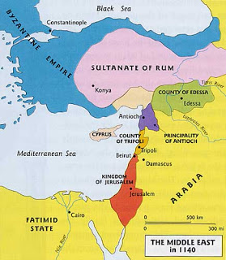

Further research:
This is not necessary, however if you would like to know the real course of the war to guide your actions, these two youtube series are very good:
- This one is a good introduction to the events leading up to and including the Crusades.
https://www.youtube.com/watch?v=HIs5B2U7US0
- This one has more military detail. https://www.youtube.com/watch?v=ydVFqpbIIwA

