UKPC: United Kingdom Parliamentary Committee

TOPICS:
The question of dealing with Novichok nerve agent crisis.
The question of dealing with the effects of Brexit on Ireland.

PARTY BREAKDOWN

Conservative Party
The current ruling party in the government, having been in power since the 2010 general
elections. Despite this, the snap election in June of 2017 saw the Conservatives lose a large
portion of their majority and causing a hung parliament. Forming a coalition with the DUP saw the eventual end to this. As their name suggests, the policies of the Conservatives are
supportive of free-markets and reduced income-tax as the primary motivators in economic
growth. Currently the Conservative Party is enacting its policy of economic austerity in a bid to slash the budget deficit. The Conservative Party has modified its social policy, and its current stance is far removed from social conservatism.
- https://www.conservatives.com/manifesto

Labour Party
The Labour Party is a centre-left party based in London. It supports the nationalisation of many industries including water systems, railway service in addition to the nationalisation of the royal mail service. On immigration, the party will not set a cap on immigrants; on Brexit, the Labour Party accepts the referendum results and works towards providing more protection for workers.
- https://labour.org.uk/manifesto/
- https://www.bbc.com/news/election-2017-39933116

Liberal Democrats
Formed through the merging of the Liberal Party and the Social Democratic Party in 1988.
Despite being the third largest party in the House of Commons as a result of the 2010 election, in the following years the party had reduced MPs - eight elected in 2015, which the increased to twelve at the 2017 snap general election. This has come coupled with two party leader changes from 2015 to 2017. The Liberal Democrats support a united, open and tolerant Britain.
- https://www.libdems.org.uk

UKIP
The UK Independence Party is a right-wing populist party and is the third largest UK party in the European Parliament with three representatives in the House of Lords and 19 Members of the European Parliament (MEPs). Despite this, the UKIP is best known for its Euroscepticism, encouraging Britain’s withdrawal from the EU. Furthermore, it has promotes a British unionist agenda, opposing the growing Scottish and Welsh nationalism.
- https://www.ukip.org/
- https://www.bbc.com/news/uk-politics-22396690

DUP
The Democratic Unionist Party (DUP) is based in Northern Ireland and supports a unified
Britain. It is also Eurosceptic and has greatly supported Britain’s leaving of the European Union. The DUP’s top five priorities include job creation, spending on health services, protecting family budgets, investing in infrastructure and education. It currently is the largest party in Northern Ireland and is the fifth largest party represented in the House of Commons as of the 2017 election.
- http://www.mydup.com/

SNP
The Scottish National Party (SNP), as the name suggests, supports Scottish independence. By membership, it is the second largest in Britain and has the third largest representation in the House of Commons. It works to achieve fairer immigration policies and providing better access to education. The SNP also has stated in its manifesto linked below their Scotland-specific targets.
- https://www.snp.org/
- https://d3n8a8pro7vhmx.cloudfront.net/thesnp/pages/9544/attachments/original/1496588087/Manifesto_2017_Easy_Read_2.pdf?1496588087

Sinn Fein
Sinn Féin is an Irish national party active both in Northern Ireland and the Republic of Ireland. It is the largest Irish nationalist party in Northern Ireland with policies focussing towards care coverage, for example affordable child care and universal health care. Furthermore, the party seeks to improve farming, fishery and rural services.
- http://www.sinnfein.ie/

TOPIC 1: The question of dealing with Novichok nerve agent crisis.

Background
On March 4 2018, the poisoning of a father and daughter, former Russian spy Sergei Skripal (aged 66) and Yulia (aged 33), by nerve agent Novichok in the town of Salisbury, Great Britain, sparked an international crisis with the United Kingdom and Russia at the forefront in a diplomatic blame game. This event has resulted in the expulsion of numerous Russian officials from UK soil, with recipricatory measures taken by Russia, as well as launching an investigation by the Organisation for the Prohibition of Chemical Weapons (OPCW) at the behest of the UK into Russia’s Novichok Programme.

With the Skripals in critical condition in a London hospital, there is much speculation over the perpetrator of the attack, and whether the Russian president, Vladimir Putin himself, was in the know how. This speculation arises after investigations into the attack have pointed out the most plausible method that the assassin used to deliver the nerve agent to the victims was through the doorknob of their Salisbury home. The risk involved in such an operation and the level of skill required to utilise this form of weapon (requiring knowledge of complex chemistry), as well as the acquisition of Novichok by the assassin, supports the claim that only members high up in Russian command could have approved and facilitated the attack, with the UK Foreign Secretary, Boris Johnson, directly accusing Vladimir Putin, “We think it overwhelmingly likely that it was his decision to direct the use of a nerve agent on the streets of the UK, on the streets of Europe, for the first time since the Second World War.” In addition, the method of attack, one which points directly to Russia with Novichok having been developed in the final stages of the Soviet Union, sends a clear signal to the Western world. Many believe that by orchestrating an attack that links readily back to Russia was the government’s way of sending a message to those defecting to the Western world. Many British and American officials have now begun to consider more carefully Putin’s use of “hybrid warfare”, and that the location of the attack highlighted Russia’s ability to extend its influence far outside the borders of its nation. Moscow has denied claims of any involvement with the attacks, and there is currently no evidence of President Vladimir Putin’s participation. Russia has in turn made allegations that the nerve agent that the UK may have produced the agent itself at its chemical defense research laboratory at Port Down, located close to Salisbury, a claim that the UK has denied as “absolute nonsense.”

Diplomatic Response to Skripal Poisonings
In the wake of the crisis, Britain has expelled 23 Russian diplomats from English soil and plans to reassess the visas of approximately 700 Russian citizens. Moscow has engaged in a tit for tat response, expelling 23 British envoys from the country. In support of Britain, the United States, Canada, France, Germany, Italy, and Poland, as well as several other EU nations have expelled Russian diplomats from the country, with Russia responding to the US’s expulsion of 60 Russians by expelling 60 American officials. This diplomatic conflict resulted in a statement by United Nations Secretary General, António Guterres, who said that the situation could be likened to the Cold War.

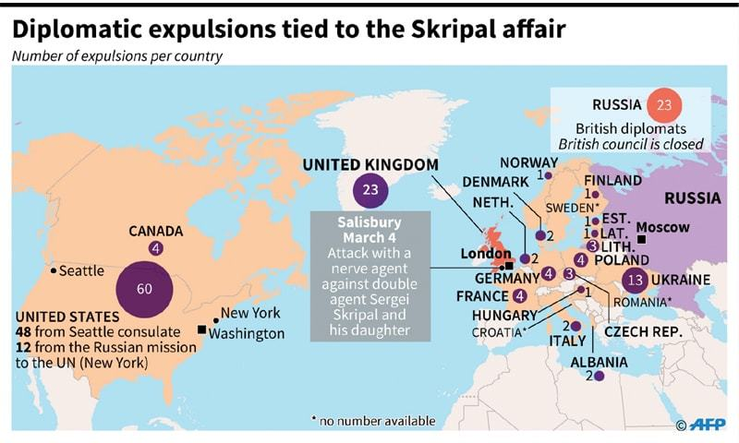
The incident has also sparked numerous OPCW investigations, as requested by Britain, into the attacks to determine Russian culpability, with an investigation into the nerve agent conducted by OPCW technicians in a Swiss laboratory drawing controversy after claims made by the Russian foreign minister, Sergei Lavrov, that the investigation had found traces of BZ in the samples from Salisbury, a chemical agent possessed by NATO member nations not Russia. However, this claim was denied vehemently, both by Western nations and the OPCW secretariat, who stated that BZ had been used as a control sample in the experiment and that the findings of the OPCW confirmed the UK’s findings on the identity of the nerve agent.

Recent Attacks in Salisbury
Four months after the nerve agent attack on Skripal and his daughter, two British citizens in Salisbury have again been poisoned by Novichok. The two victims, a man and woman in their 40’s, have reportedly fallen ill after a visit to Salisbury near the location where the attack on the Skripals took place. This incident heightens the public threat of the nerve agent, and highlights that the activities undergone by British authorities in order to decontaminate the area weren’t as successful as the public assurances by the authorities espoused. There is also the possibility that the exposure was due to a more recent attack, which brings about the additional threat that the Novichok attack was not a one-time incident.

Current Political Climate and Attitudes
As of now, tensions remain high within the sphere of the general public, with the general sense of urgency to charge and uncover the perpetrators behind what has been perceived by many an ‘act of war’ by the Russians on British soil. Furthermore with the current escalation by Theresa May through the expulsion of 23 russian diplomats, the MPs will be held to standard through the eyes of the general public if no plausible action has been taken. Currently, the Kremlin has denied any involvement in the recent poisonings and has an open offer to partake in a joint investigation. It is highly urged that a bill be formulated efficiently outlining future action, addressing current foreign policy and how to better foster diplomacy within the international scope, with British-Russian relations remaining strained.

Key Terminology
Novichok Nerve Agent
Novichok is one of the most debilitating agents in the family of compounds known as the organophosphate compounds. These nerve agents work by inhibiting the enzyme acetylcholinesterase which regulates the message from nerve to muscle. This inhibition causes muscles to spasm, and affects a wide range of function including that of the lungs and heart. If untreated, this can be fatal. The name Novichok means “newcomer” in Russian, and these nerve agents were developed in the Soviet Union during the 1970-80’s under a Soviet programme with the codename Foliant. The chemical formula for the agent was released to the world, through the publication of book ‘State Secrets’ by Russian defector, chemist Dr Vil Mirzayanov, in the 1990’s.

OPCW
The Organisation for the Prohibition of Chemical Weapons was established after the adoption of the Chemical Weapons Convention in 1992, to enforce the stipulations of the treaty which bans the usage, stockpiling or transfer of chemical weaponry by signatories to the convention. The headquarters of the OPCW is in the Hague, Netherlands. The OPCW has the authority to perform inspections to ensure that signatories remain compliant with the terms of the treaty, including access to all chemical weapons facilities and testing of sites of victims of chemical weapons attacks. Through the 2001 Relationship Agreement between the OPCW and the United Nations, the OPCW is mandated to report its activities and findings to the UN through the Secretary General’s office.

Timeline (History of Chemical Weapons Usage/Development)
Date | Event
1925 | After the usage of chemical weapons during World War 1 with debilitating effects on soldiers that persisted decades after the War had ended, the Geneva Protocol signed 1925 by the major powers Austria, Britain, France, Germany, Russia, and the USA, prohibited the use in war of ‘asphyxiating, poisonous or other gases and bacteriological methods of warfare.’ However, the treaty did not ban the production or stockpiling of these weapons, and the majority of the signatories continues their development of lethal chemical weapons.
1936 | The first nerve agent was developed by German chemist, Gerhard Schrader, in the Third Reich during an investigation into potential pesticides. The agent developed, tabun, proved to be too toxic to use on crops, and a year later an even more toxic agent, sarin, was developed. German munitions were developed with these agents during World War 2, however none were employed against Germany’s opponents, potentially due to Hitler’s personal revulsion against chemical weapons after his exposure during World War 1.
1935-1936 | Chemical weapons attacks by Italy were used in Ethiopia (then Abyssinia), specifically the blister agent sulphur mustard, with sulphur mustard air bombs resulting in the majority of chemical weapons casualties.
1950’s | Post World-War 2, the Western World became privy to the chemical knowledge of German scientists, and the evolution of chemical weapons went underway, with the development of longer living agents by the UK including the notable agent VX, used in the 2017 assassination of King Jong-Un’s half brother in an Kuala Lumpur airport.
1963-1967 | Chemical weapons employed Egypt in attacks in Yemen, with the Egyptian use of CW during the Yemen War making it the first Arab state to employ the chemical agent CW, with acquisition of the nerve agent from the Soviet Union in the 1960’s.
1983-1988 | Chemical weapons employed by Iraq in attacks in Iran and Kurdistan (many civilian casualties), including the use of blister agent mustard gas in 1983 and the nerve agent Tabun from 1985. Civilian Kurdish casualties from chemical weapons usage on Kurdish cities were great, with up to 5,000 civilian deaths resulting from the 1988 bombing of the Kurdish city of Halabja.
1993 | Evidence of the Iraqi attack on Kurdish civilians hastened discussions of a chemical weapons treaty at the UN Council of Disarmament. In 1993, the Chemical Weapons Convention was adopted, and in 1997 became international law following ratification by 65 member nations. Today, 192 nations are signatories to the treaty, with the only exception being North Korea, Israel, South Sudan, and Egypt, however these nations are still bound by the provisions of the treaty under national law.
2013-2017 | An OPCW Fact-Finding Mission (FFM) confirmed in June 2017 that the Syrian government exposed its civilians to Sarin in the Khan Shaykhun region of the Syrian Arab Republic. The report was shared with State Parties to the Chemical Weapons Convention and the UNSC. Through 2010-2017, both the Syrian Government and the Islamic State have been found responsible for conducting chemical weapons attacks on civilians, violating the CWC which Syria is a signatory of.

Solutions:

Strasbourg Agreement 1675
The strasbourg agreement of 1675 was the first international agreement which banned the use of chemical weaponry. The treaty was signed between France and the Holy Roman Empire in response to the use of poisonous bullets.

Geneva Protocol
The 1925 Geneva Protocol prohibits the use of chemical and biological weapons in war. The Protocol was drawn up and signed at a conference which was held in Geneva under the auspices of the League of Nations from 4 May to 17 June 1925, and it entered into force on 8 February 1928.

Chemical Weapons Convention (CWC)
The full name of the CWC is the Convention on the Prohibition of the Development, Production, Stockpiling and Use of Chemical Weapons and on their Destruction. It treaty stands as an arms control treaty which aims to eliminate the entire weapons of mass destruction by prohibiting the development, production, acquisition, stockpiling, retention, transfer or use of chemical weapons by States Parties.

UN Security Council resolution 2118
The Security Council resolution was adopted with a unanimous vote on 27 September 2013 in regards to the goal to eliminate Syria’s chemical weapon. The resolution contains several international agreements which call for the elimination of Syria’s chemical weapon and furthermore has a set destruction deadline.

Resources for Further Reading
- https://www.bbc.com/news/uk-45421445
- https://www.bbc.com/news/uk-45444080
- https://www.theguardian.com/politics/2018/jul/05/sajid-javid-uk-to-consult-allies-over-novichok-response-russia-poisoning
- https://www.bbc.com/news/av/world-europe-45508079/skripal-suspects-deny-involvement-in-salisbury-novichok-poisoning

TOPIC 2: The question of dealing with the effects of Brexit on Ireland.

Background
Brexit has been a pertinent issue in recent years, with extreme controversy and further implications. Britain’s exit from the European Union or Brexit took place on June, 23rd, 2016 when a national referendum was held on the grounds of whether Britain should leave the European Union or not, With a leave vote of 51.9% to 48.1% Britain has possessed to leave the European Union
which is scheduled to depart at 11pm UK time on 29th March, 2019.

What is the European Union?
The European Union is an economic and political partnership involving 28 European countries.
It’s creation began after World War Two to foster economic co-operation and bolster
international peace, with the idea that countries which trade together are more likely to avoid
going to war with each other. The UK joined in 1973. From then, the EU has developed to
become a "single market" allowing goods and people to move around, as if the member states
were one country. It has its own currency, the euro, which is used by 19 of the member
countries, its own parliament and it now sets rules in a wide range of areas - including on the
environment, transport, consumer rights and even things such as mobile phone charges.

Good Friday Agreement
The Good Friday Agreement was established on Friday the 10th of April 1998. The agreement was between the British and Irish government which outlined how Northern Ireland should be governed. This was in an effort to implement a nationalist and unionist power-sharing government in Northern Ireland. In regards to whether Northern Ireland should remain in the UK or unify Ireland the ‘principle of consent’ was enacted whereby it prohibited any change without the consent of the majority. As a result of Northern Ireland voting to remain in the EU, issues have rose in regards to the DUP, whereby neither Arlene Foster nor Theresa May has any mandate to remove Northern Ireland from the EU, to impose a hard border and rip up the Good Friday Agreement. In consequence to impose any of these would give grounds to trigger a unity referendum, provided for within the terms of the GFA, which may result in the reunification of Ireland regardless.
Political Violence
Currently the British government faces the issues of rising paramilitary movements within Ireland such as the Irish Republican Army (IRA) which strongly advocates for the indepence of the republic from British rule, in favor of forming their own government. They have been held accountable for numerous violent outbreaks in Ireland which have resulted in deaths.

This is due to the fact that a ‘No-deal’ could reignite conflict, as a keystone of the Good Friday Agreement was to keep the border between the Northern Ireland and the Republic of Ireland open, which will be dismantled as a no-deal scenario will result in reinstating hard borders which could be detrimental as it would lead to a resurgence of paramilitary activity.

The region also stars a centuries-old divide between Catholic Nationalists, who align themselves with Ireland, and Protestant Loyalists, who align themselves with the U.K. During the 20th century, this tension resulted in the Troubles, a 30-year conflict which resulted in nearly 4,000 deaths and 50,000 injuries. While the scale of the violence has died down since the 1998 Good Friday Agreement, simmering tensions remain. Bomb threats and rioting are a regular occurrence. The government must take this into account when formulating bills to prevent as little social unrest as possible.

Northern Ireland
The land border between Northern Ireland and EU member the Republic of Ireland has been a
vital part of the Brexit talks as there is currently a common travel area between the UK and the
Republic. Like Scotland, Northern Ireland voted to remain in the EU in last year's referendum.
The result in Northern Ireland was 56% for Remain and 44% for Leave. Both sides agreed they did not want a return to a "hard border" - that means no physical infrastructure, such as customs posts, but the wording to agree on this proved tricky. What has been agreed is that the UK 'will maintain full alignment with those rules of the Internal Market and the Customs Union which, now or in the future, support North-South cooperation, the all island economy and the protection of the 1998 Agreement'.

Republic of Ireland
Outside of the UK, the Republic of Ireland is the country that will be most affected by Britain's exit from the European Union. This is due to the fact that UK is one of the largest customer for Irish goods. The border between the Republic of Ireland and Northern Ireland, which is a part of the UK, will become the frontier between the EU and an external country after Britain's scheduled departure from the block on March 29, 2019. The government must navigate through the rules regarding through the EU’s rules on trade standards products and the single market.
The Cost of Brexit on Ireland
Brexit will indefinitely have an effect on the British economy as well as the Irish. According to an independent research team, backed by Copenhagen Economics for the Government states that ideally, in 2030 Irish GDP have a 2.8% reduction as a result of Brexit. However, at worst, high tariffs as a result of the UK and EU upon their products could lead to a 7% reduction in GDP in consequence to a ‘hard’ Brexit. As a result of this, both Irish exports and imports will be subject to damage. Currently the most vulnerable sectors are agri-food, pharma-chemicals, air transportation, electric machinery and retail, but also web companies. All of these will require special focus in taking account minimising the damage to Ireland.

It has been displayed that the Republic of Ireland would be extremely vulnerable in the event of a ‘hard’ Brexit whereby the International Monetary Fund (IMF) predicts that Ireland’s economic growth will take a 4% blow where it would cost households around €1,400 a year. This can be prevented through bolstering extra customs and veterinary staff to man ports and airports as well as increase training in sectors likely to be affected.
Furthermore, Ireland faces the issues regarding Brexit’s impact on its economy in relation to the single market. This means the government should put special emphasis in navigating through trade negotiations with other partners and regulation. This will mitigate Brexit’s adverse effects on other areas except tariffs and border taxes. In the case that Britain successfully negotiates a deal with the EU, Ireland has to look to strengthening trading relations with other countries such as countries in South America, Australia and New Zealand. As well as this, with the new FTAs being concluding, trading with Japan and Canada may yield to some benefits.
Another alternative would be implementing a domestic policy that would increase trading channels through new markets and businesses. For example, Brexit stands to have a large impact on the gambling industry as it represents a large sector of the economy. Regardless, Ireland cannot afford to lose billions of euros and the government should come to a quick and effective decision that will ameliorate the negative effects when Brexit will become a reality.

The Irish Border Brexit Backstop
The backstop plan is a contingency plan designed to circumvent protocols installing a hard border in Northern Ireland. This can be implemented if appropriate customs arrangements cannot be agreed to by both the EU and the UK during the allocated transition period in december 2020. This allows Northern Ireland to stay and participate in the single market for goods and the customs union until the UK can formulate a plausible solution to the borders. However Theresa May has strongly advocated for a backstop which could result in the UK remaining part of the customs union after the transition period, to the behest of the EU.

This provides an alternative route to take in negotiating border terms with the EU in order to protect commitments made to Northern Ireland in the Good Friday Agreement.

Timeline
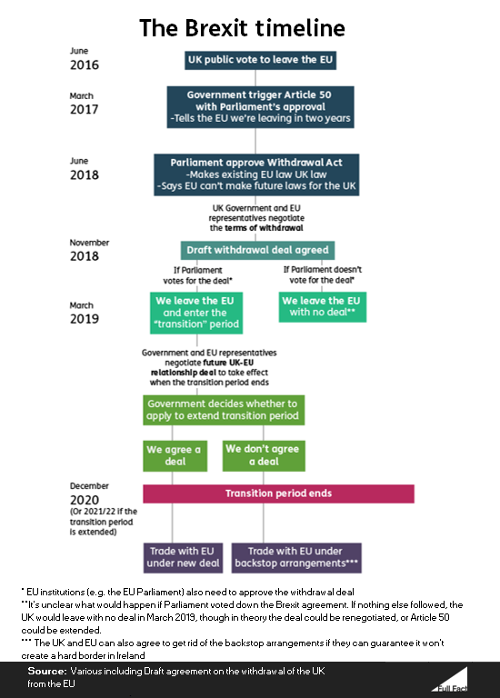
Resources for Further Reading/ Sources
- https://www.bbc.com/news/uk-politics-32810887
- https://en.wikipedia.org/wiki/Irish_Republican_Army
- https://www.independent.ie/business/brexit/avoiding-a-hard-border-in-ireland-requires-more-than-simply-saying-it-wont-happen-may-warns-37684476.html
- https://thinkprogress.org/how-a-no-deal-brexit-could-create-chaos-in-northern-ireland-e9ac8f25e135/
- https://www.irishtimes.com/news/world/brexit/brexit-the-facts
- https://www.bbc.com/news/uk-northern-ireland-462025

