Forum: United Nations Security Council
Issue: The Question of the Conflict in the South China Sea
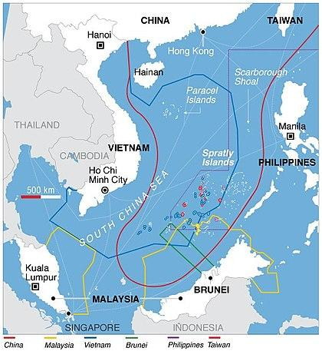
Introduction
In recent years, China has continuously expanded and asserted its influence beyond mainland Chinese borders, especially into the nearby seas and South East Asia. In 2009, China submitted a claim to the United Nations over the region encapsulated by the “nine-dash lines”. It includes most of the South China Sea, a body of water which borders nearly all South East Asian nations and around $5.3 trillion of trade travels through it each year. China claims sovereignty over the Sea and many of its important landmarks, including the Scarborough Shoal, Paracel Islands, Spratly Islands, the Macclesfield Bank, and the Pratas Islands, conflicting with competing claims of virtually all nearby coastal nations. Since then, China has systematically enforced its claim by expanding its naval presence and ignoring sovereignty of most other nations in the region. In the process, China has strained relations not only with the local countries of Philippines, Vietnam, Malaysia, Brunei, Taiwan, but also with Japan, the European Union (EU), and the United States. The Association of Southeast Nations (ASEAN), of which many member nations hold competing claims with that of China over the region, are part of is expected to play a vital role in mitigating this conflict.
According to the United Nations Convention of the Laws of the Sea (UNCLOS), each sovereign nation has a right to an Exclusive Economic Zone (EEZ), which includes rights to exploitation of maritime resources and energy. However, due to the rich nature of the region, the nations in question are moving towards ignoring the EEZ to stake a claim for their own benefits. Thus, the diplomatic dispute spans numerous different issues of trade, military influence, and natural resources among other cultural and political debates.

History
The South China Sea Dispute is caused by overlapping claims on maritime regions and land masses between eight countries in the region. The territory in question borders People’s Republic of China (PRC), the Republic of China, the Philippines, Malaysia, Brunei, Indonesia, Singapore, and Vietnam.
Housing some of the most lucrative trade routes in the world and a plethora of natural resources, the contentious region has had a turbulent history in the last few decades with territorial and maritime claims holding varying degrees of legitimacy. France maintained claim over the Spratly Islands during its colonial administration of Indo-China, consisting of modern day Laos, Cambodia, and Vietnam. Great Britain also maintained claims in the regions bordering Malaysia and Northern Borneo until the abolition of British colonialism. In both cases, the status of these claims became unclear after the end of colonialism in the region with multiple nations fighting for each of their claims.
Since the 17th century, Vietnam has also actively ruled over both the Paracel and the Spratly Islands. They lost these regions to Japanese occupation during the Second World War, and the PRC sent their navy to “reclaim” the islands after Japan’s surrender. However, in the peace treaty with Japan from 1951, the islands’ statuses were not clarified.
The nine-dotted line defined by the PRC that outlines their territorial claims has its origins in an eleven-dotted line created by the Kuomintang Party in 1947. After communist party’s victory in taking over the mainland, they adopted the claims created by the Kuomintang, resulting in the nine-dotted line, which currently encompasses most of the South China Sea starting from the Southern Chinese province of Hainan and including both the Paracel and the Spratly Islands. Both Taiwan and the PRC derive their claims from two thousand years of history of Chinese presence in the region, in which the island chains were considered integral parts of China. Nearly all other nations and international organizations do not recognize their claims.
Throughout recent decades, there has been an increasing number of skirmishes in these regions, as all interested parties have made attempts to assert military dominance. In 1974, the PRC forcibly took control of the Paracel Islands which was under Vietnamese control at the time and killed over 70 Vietnamese troops in the process. At the Spratly Islands in 1988, another clash occurred between Vietnam and China, resulting in another 60 civilian deaths of sailors. Other counties such as the Philippines have also been in conflict with Vietnamese and Chinese influence in the region. One of the most important major developments of the issue has been China’s plan of creating “Sansha city”, a framework for an administrative prefectural level government with control over a significant region including the Spratlys, Paracels, Scarborough Shoal, and Woody Island. It has been seen by other countries as a way for the PRC to enforce maritime laws and entrench Chinese military presence.
Numerous conflicts have plagued the region since, with the Philippines taking China to a UN tribunal under UNCLOS after the PRC forcibly took over the Scarborough Shoal formally under Philippines control. In 2016, the Permanent Court of Arbitration (PCA) ruled for the Philippines, stating China had breached the sovereignty of the Philippines and caused extensive environmental damage. They also reiterated that the nine dashed line had no legal backing and could not be enforced. With 121 contracting parties, the PCA was acknowledged as an international court that ruled on disputes where solutions would be difficult to solve through diplomacy by the 1899 and 1907 Conventions for the Pacific Settlement of International Disputes. The PCA is weaker than the International Court of Justice, as it lacks the power of Article 94 in the UN Charter, which allows breaches in the ICJ’s ruling be brought up to the UNSC for further measures. China has publicly denounced the PCA ruling, declaring it unlawful. While the United States and the United Kingdom strongly endorsed the ruling, many other UNSC members and other countries were hesitant in directly rebuking China, highlighting the numerous intertwined interests of the countries at hand. Even with the ruling, China is still maintaining and expanding their military presence in the region, worsening the problem at hand.

Current Situation
Despite the 2016 PCA ruling, China has increasingly expanded its claims in the region. Other nations’ distrust of China has been exacerbated by these numerous incursions into their sovereignty by both the PRC and independent Chinese fishermen.
China have been emboldened by the lack of repercussions to their illegal takeover of the Scarborough Shoal, which has resulted in the construction of numerous artificial islands in the region to greatly extend the reach of China’s air force, coast guard, navy, and fishing fleets in the span of a few years. In response, the United States has been taking more direction against Chinese proliferation in the region. The Obama Administration deployed the USS Lassen, which was ordered to travel close to 12 miles of the Spratly’s and Subi Reefs. China has also been declaring Air Defense Identification Zones (ADIZ), an airspace where all aircraft including civil ones is identified and control for national security. The US has refused to accept these spaces and has flown armed gunships through the ADIZ. To counteract, the Chinese People’s Liberation Army (PLA) has been deploying their own fighters and warships to the region, straining tensions even further.
Many close encounters have occurred between the US and Chinese forces in China’s EEZ. In December 2013, a Chinese amphibious dock ship and USS Cowpens, a US missile cruiser, where the dock ship halted in front of Cowpens after it refused to leave the area. Cowpens only stopped 500 yards away from the dock ship, nearly resulting in a Collision. Another notable encounter was in August 2014, where a Chinese fighter jet attempted to intercept a Navy Poseidon P-8 aircraft 135 miles east of Hainan Island. Rules of military encounter have been set up since these incidents to prevent such incidents from the future.
The PRC has further augmented these islands by constructing cities with military structures such as airbases and ports on them, moving military personal and equipment there as well. Chinese citizens are encouraged to settle these islands to further solidify Chinese claims to these oceans. Hence, members of the international community in addition to nations with competing claims to the South China Sea view China’s actions as not only infringing on surrounding nations’ sovereignty but also as growing military threats as well. Some countries, such as Vietnam and Taiwan, and Indonesia, whose relations with China are already tense, are even more worried, as the PRC has ignored all their warnings and open conflict seems to be inevitable.
Another potential crisis is the ripple effect of the South China Sea Dispute with other issues in the region. Other countries have other ongoing disputes with China in neighboring regions such as Japan regarding the Senkaku Islands or Taiwan in controlling strategic marine waterways, and the South China Sea dispute has further exacerbated tensions. The United States and its allies also have an interest in maintaining free navigation, especially for commercial shipping and the peaceful resolution of territorial disputes. No one wants to put the 5 trillion dollars of trade passes through the region at stake. If China continues its provocations, the US is compelled to respond to maintain credibility in South East Asia and the East Sea. However, Washington is also concerned about Sino-American cooperation being crucial to dealing with other problems such as terrorism, climate change, or North Korean nuclear threats.
Even though the Association of Southeastern Nations (ASEAN) consists of many of the nations affected by the South China Sea Dispute, it has mostly ignored this issue, choosing to focus on other economic development projects such as the Belt and Road Initiative (BRI). Many local leaders have stressed the need for maritime cooperation, but most declarations do not go further than stating that a code of conduct should be established. Some experts believe a more firm US stance may galvanize the other member states to take comprehensive action through this organization.

Definition of Key Terms
The South China Sea
The South China Sea is a marginal sea part of the Pacific Ocean that extends from the Karimata and Malacca Straits to the Strait of Taiwan, encompassing an area of up to 3,500,000 square kilometers. The territory is considered to hold significant strategic importance since one-third of international shipments passes through transporting over three trillion dollars in trade annually. Its significance also lies in the abundance of lucrative fisheries that are crucial for food security among Southeast Asian nations, as well as oil and gas reserves that lie beneath the seabed.

United Nations Convention on the Law of the Sea
The UNCLOS is a set of documents that lays down a comprehensive regime of law and order in international ocean territories and establishes rules governing all uses of the oceans and their resources. More specifically, it comprises of 320 articles and nine annexes, governing aspects such as delimitation, environmental control, marine scientific research, economic and commercial activities, transfer of technology, and the settlement of disputes relating to ocean matters. The convention allows international disputes regarding ocean space to be addressed through an internationally-recognized system that removes potential bias and controversial standards.

Exclusive Economic Zone (EEZ)
An exclusive economic zone (EEZ) is a sea zone prescribed by the UNCLOS over which a state has special rights regarding the exploration and utilization of marine resources, such as but not limited to energy production from water and wind. Such territories stretch from the baseline out to 200 nautical miles from the coast, but does not include either territorial sea or continental shelf beyond the 200 nmi limit. According to article 55: Specific legal regime of the exclusive economic zone, “the exclusive economic zone is an area beyond and adjacent to the territorial sea, subject to the specific legal regime established in this Part, under which the rights and jurisdiction of the coastal State and the rights and freedoms of other States are governed by the relevant provisions of this Convention.”
The difference between the territorial sea and the exclusive economic zone is that the first confers full sovereignty over the waters, whereas the latter is merely a sovereign right that refers to the coastal state’s rights below the surface of the ocean.
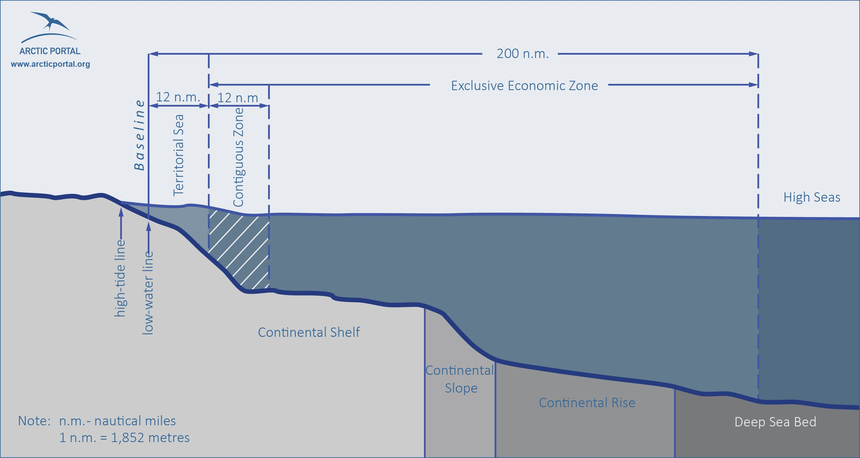
Freedom of Navigation Operations
Freedom of navigation (FON) is a principle of customary international law that ships flying the flag of any sovereign state should not be interfered by other states. This right is codified as article 87.1 of the UNCLOS; not all UN member states have ratified the convention, and notably, the United States has signed but not ratified the convention.
Major Parties Involved and Their Positions
People’s Republic of China
China is one of the main claimants of the South China Dispute, claiming the huge swath of territory defined by the “nine-dash-line”, which encompasses hundreds of miles south and east of Hainan. They claim the Paracel and Spratly Island chains based on their history when the islands were once considered part of the Chinese nation. The claims were filed in 1947 and has been hotly disputed by all neighboring countries and the international community since. They have refused to accept the PCA ruling and continued their efforts in colonizing and militarizing the region. It has also been directly opposing US intervention in the area, as shown by the aggressive military maneuvers performed by its navy.
United States of America
Though the US lacks any territorial claims in the region, it has emerged as one of the leading interest groups on the issue, to prevent further spread of Chinese influence. Interestingly, the United State has not ratified UNCLOS, but hopes a solution can be reached through legal methods in this conflict. They have also been matching the Chinese military presence of the region with conducting military drills along with US allies such as Vietnam and adding further navy deployments to the region. If the disputes escalate into military conflict, the United States is compelled to be involved due to its defense treaty with the Philippines.
Russian Federation
While Russia has not been as involved as the other P-5 members, they have shown an avid interest in cultivating closer relations with South-East Asian nations and expanding their influence in the region. They have recently expanded on their mutual defense pact with Vietnam, along with another military contract that gave Vietnam two more Geperd-class frigates. Yet, Russia has also not abandoned China, its ally, as they hosted a Sino-Russian naval exercise in September. With its interests in the region, Russia is definitely a third party to keep watch in resolving the South China Sea.
Republic of France and United Kingdom
While the South China Sea is distant from their borders, both countries have been staunch supporters of the United States, recently sending their warships to sail through the region as a sign of solidarity with the PCA ruling. Australia and Britain have also been in talks to station HMS Queen Elizabeth, an aircraft carrier to the Pacific, which may escalate tensions further.
ASEAN
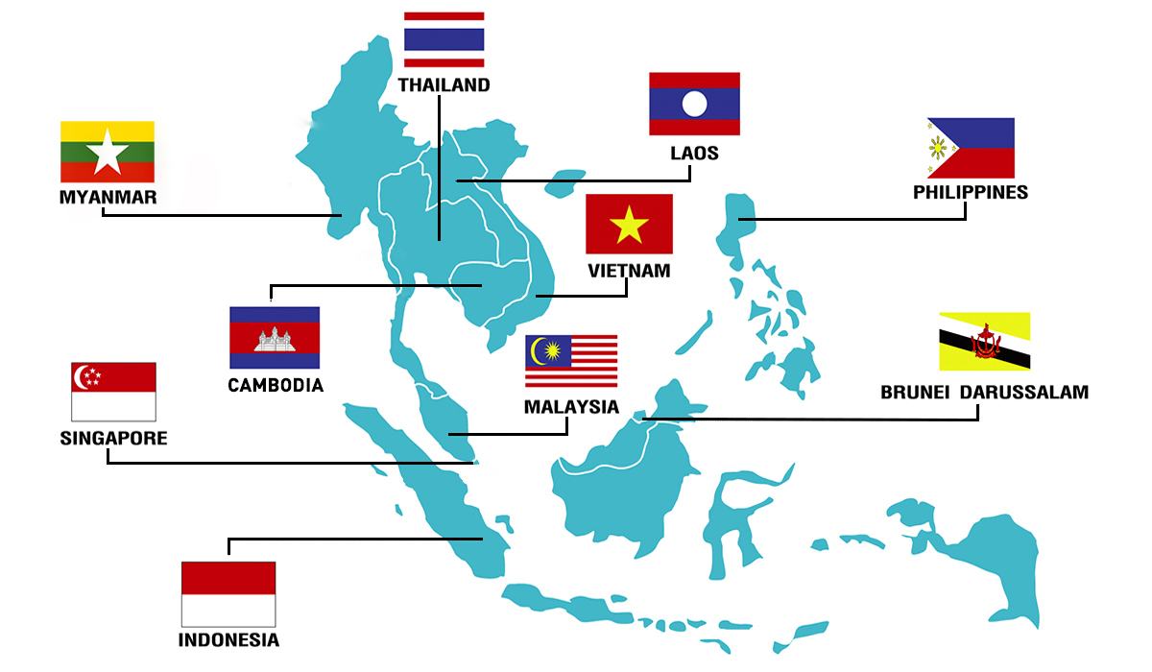
Most of the Association members have a stake in the issue being Brunei, Darussalam, Cambodia, Indonesia, Laos, Malaysia, Myanmar, Philippines, Singapore, Thailand, and Vietnam. With the Code of Conduct of Parties in the South China Sea, a framework for dialogue and cooperation between these countries was created. While ASEAN has not been directly involving itself in the South China Sea Dispute, its influence in the region may make it a crucial part in resolving the conflict at hand.
State of Japan
With previous and continuing territorial disputes with China in the East Sea, Japan hopes the status quo is maintained in the South China Sea as international waters. Due to increasing aggressive moves orchestrated by the Chinese government, Japan has been more actively supporting the United States and its allies in their efforts in the South China Sea.
Socialist Republic of Vietnam
Vietnam directly disputes with China’s historical basis, stating it has ruled over both the Paracels and Spratlys Islands from the 17th century. After the Johnson South Reef Skirmish in 1988, Vietnam is heavily vested in creating a code of conduct to prevent further casualties and more skirmishes.

Relevant Documents
- Bonnie S. Glaser, “Conflict in the South China Sea,” Council on Foreign Relations, April 4, 2015, https://www.cfr.org/report/conflict-south-china-sea.
- “Why Is the South China Sea Contentious?,” BBC News, July 12, 2016, sec. Asia, https://www.bbc.co.uk/news/world-asia-pacific-13748349.
- Center for Strategic and International Studies. “Tensions in the South China Sea Explained in 18 Maps.” Business Insider. March 11, 2016. Accessed September 19, 2018. https://www.businessinsider.com/tensions-in-the-south-china-sea- explained-in-18-maps-2015-1#1a-political-map-1.
- Tham, Jansen. “Is the South China Sea Dispute a Foregone Conclusion?” The Diplomat. May 10, 2018. Accessed September 19, 2018. https://thediplomat.

Possible Solutions
While the UNSC is heavily invested in resolving the crisis in a peaceful manner, there are many possible routes of action the UNSC can take. That can take dif
International Courts
Three international courts should be considered: International Court of Justice (ICJ), International Tribunal for the Law of the Sea (ITLOS), and the Permanent Court of Arbitration (PCA). As the principal judicial organ of the UN, the ICJ rules on disputes between member states and/or provide advisory opinions to other principle UN organs or certified agencies.
Recently, the ICJ has ruled over a number of cases dealing with maritime borders and sovereignty such as the disagreements on the delimitation of the continental shelf. ITLOS was created by UNCLOS to oversee any cases regarding the legal interpretation and application of UNCLOS. The PCA has already ruled on Case No. 2013-19, in which China’s actions in the South China Sea was declared a breach of international law and UNCLOS. However, there have been difficulties in enforcing the ruling as China has refused to accept any of the provisions.
Non-Judicial Actions
Beyond legal actions, the Security Council is not limited to judicial methods. According to Chapter VI of the UN Charter, the UNSC may consider the use of arbitration, mediation, and cooperation with regional organizations, in this case ASEAN, to settle the dispute. The UNSC can also initiate political missions to manage long-term peacekeeping projects in regions of conflict and disputed regions, by cooperating with the UN Department of Political Affairs and the Peacebuilding Commission. For further escalation of the conflict, the Chapter VII of the UN Charter could be invoked, which oversees “actions with respect to threats to the peace, breaches of the peace, and acts of aggression” and the possible methods that could solve these problems.

Questions to Consider
- How does the involvement of non-claimant nation states like the United States either dictate or fail to influence the dynamics of the international dispute?
- Given the role of the UNCLOS and the previous reactions of claimants (namely China) to what the international community agrees as being fair third party arbitrations, what can the UNSC do to prevent the escalation of current tensions?
- Considering the wealth of possible oil and natural gas reserves, as well as aquacultural biodiversity in the region, how do we combat the tragedy of claimant nations not only act out of self-interest, but out of competitive, militaristic zeal?
- How do the tangled economic situations of the involved nations affect their geopolitical stances and reactions to international legislation and conciliation?

Bibliography
- Beian Xu. “South China Sea Tensions.” Council on Foreign Relations, May 14, 2014. https://www.cfr. org/backgrounder/south-china-sea-tensions.
- “Why Is the South China Sea Contentious?” BBC News, July 12, 2016, sec. Asia. https://www.bbc. co.uk/news/world-asia-pacific-13748349.
- Raymond, Greg. “The South China Sea Crisis: Next Stop the UN Security Council?” Text. The National Interest, May 30, 2016. https://nationalinterest.org/blog/the-buzz/the-south-china-sea-crisis-next- stop-the-un-security-council-16397.
- “The Tribunal.” International Tribunal for the Law of the Sea. Accessed August 6, 2018. https://www. itlos.org/en/the-tribunal/.
- “Pentagon: China Tried to Block U.S. Military Jet in Dangerous Mid-Air Intercept.” Washington Post. Accessed August 2, 2018. https://www.washingtonpost.com/world/national-security/pentagon-china- tried-to-block-us-military-jet-in-dangerous-mid-air-intercept/2014/08/22/533d24e8-2a1b-11e4- 958c-268a320a60ce_story.html.
- Diplomat, Carl Thayer, The. “USS Cowpens Incident Reveals Strategic Mistrust Between U.S. and China.” The Diplomat. Accessed August 2, 2018. https://thediplomat.com/2013/12/uss-cowpens-incident- reveals-strategic-mistrust-between-u-s-and-china/.
- Greg Torode. “Vietnam Builds Military Muscle to Face China | Reuters.” Reuters, December 18, 2015. https://www.reuters.com/article/us-vietnam-china-conflict-insight-idUSKBN0U000320151218.

