United States Congress Committee
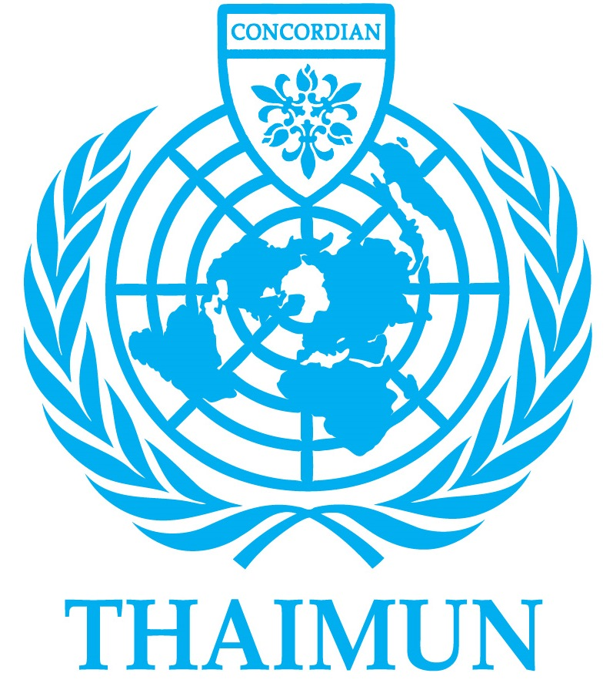
Senate chairs: Pasit Laosethakul; Dhruv Mittal.
baconpasitl@gmail.com; dhmi19@patana.ac.th;

Backroom chairs: Matthew Muehleck; Andy Park.
matthew.muehleck@gmail.com; parj@ise.ac.th;
Topics to be debated: The question of dealing with the trade war with China;
The question of Russian interference in the 2016 US Election;

THAIMUN V Chair Report
United States Congress Committee

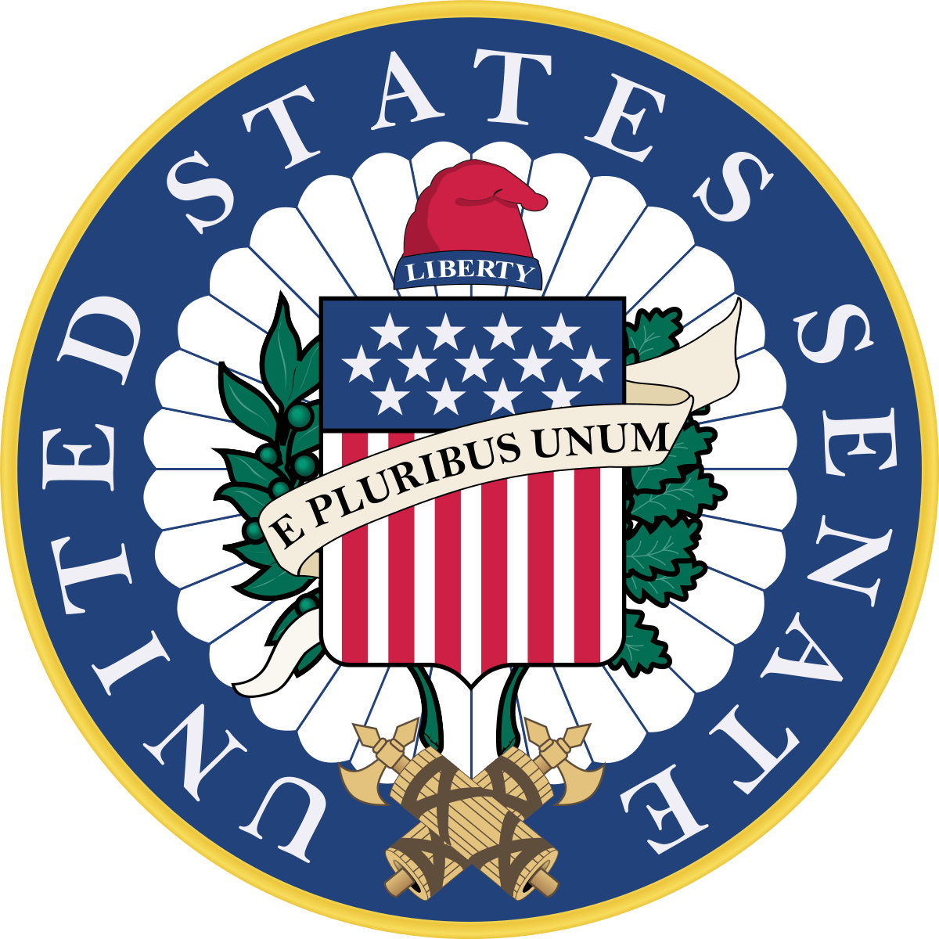

Senate Chairs: Pasit Laosethakul and Dhruv Mittal
Senate Backroom: Matthew Muehleck and Andy Park

Committee Overview
Structure of the American Government
Following the implementation of the Constitution of the United States of America in 1787, three autonomous branches of government - Legislative, Executive and Judicial - were created, each with a distinct role.
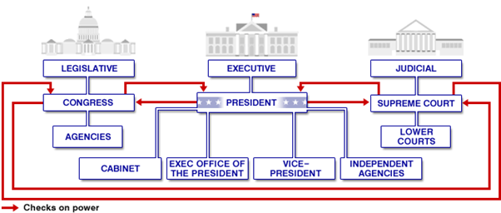
Figure 1: a simplified diagram of the ‘Checks and Balances’ system that exists between the three branches of government, BBC News

The Legislative Branch (Congress) is the law-making organ of the government. It has two different parliaments: the House of Representatives and the Senate. Each state’s representation in The House of Representatives is determined by its population (proportional representation). For instance, California has fifty-two representatives, while Vermont has one. The Senate - the second assembly of the Bicameral Congress - also consists of representatives (Senators) from each state, but has a fixed number of two Senators per state (equal representation). For a bill to be made law, it is required to pass through both the House of Representatives and the Senate.

Based in the White House, the Executive Branch is headed by the President of the United States. The President’s role, as stated in the Constitution, is to “take care that the laws be faithfully executed” and to, as said in the Oath of Office, to “preserve, protect and defend” the Constitution.

Lastly, the role of the Judicial Branch, of which the Supreme Court is the highest court of land followed by the Federal Court (State Level); is to ensure that the articles of the Constitution are upheld, and that the laws created by the Legislative Branch are exercised.

The power of the government is split amongst the three branches to ensure that a single person or group does not gain too much control; each branch complements the powers of the others, but also limits their powers. For a more detailed explanation of the composition of the government, visit: http://www.history.com/topics/checks-and-balances.

Although the THAIMUN United States Congress Committee models the Senate, it is important to understand the roles of other governmental branches as the ‘Checks and Balances’ system will be replicated: decisions and directives will pass through the Backroom Chairs who will act as the relevant third party (for instance, the House of Representatives).

The purpose of the Senate
The responsibility of the Senate includes accepting treaties with other countries. It also has the responsibility of confirming presidential appointments (e,g. judges, cabinet members and foreign ambassadors) and can even block appointments, forcing the President to choose someone else for the job. The Senate is also responsible for investigating matters of national interest (for instance, the Vietnam War). These are examples of how the Senate checks on the other branches of government (Checks and Balances).

More Congressional Powers
The common powers of the Congress are listed in Article I Section 8. These are the enumerated or delegated power of Congress. They include the power to
- Collect taxes, pay debts, and provide for the common defense and general welfare
- Borrow money
- Regulate commerce among the states (interstate commerce) and with foreign countries
- Establish uniform laws dealing with immigration, naturalization and bankruptcies
- Coin money
- Make laws regarding the punishment for counterfeiting
- Establish post offices
- Make copyright laws
- Establish federal courts in addition to the supreme court
- Define and punish piracy
- Declare war
- Raise and support armies and a navy
- Create a national guard

Senators should note that although the congressional powers listed above may not be directly relevant to the topics being debated, they may be useful for reference.

The post-Trump Senate

The climate of the Trump-era Senate has rather been tense and been widely criticized by both the President and the public. Donald J. Trump has often expressed his disappoint in Republicans failing to follow through is policies through Twitter. While the public, the liberals often criticize the Democrats for not going far enough to represent the interest of the liberal voters and the conservatives especially Trump voters who often view The Senate Majority leader to be too weak and not supporting Trump enough to help Trump “drain the swamp” in Washington.

The Republican party currently has a majority in the Senate with 51 seats, while the Democrats hold 47 seats and thus are the minority party. The remaining two seats are held by Independent Senators. With Republicans having a very small majority in the Senate, the Republicans will have to count on Democrats and Independent Senators to pass through major legislation.

Despite the Republicans controlling both the Congress and the White House, under President Donald J. Trump’s administration, the government has failed to pass many important bills during the first year in office. For example, a bill to repeal and replace Obamacare which the Republicans has vowed to do in the past three elections, and recently, the appropriation (budget) bills to fund the federal government which led to United States Federal Government Shutdown of 2018 from January 20th to January 22nd, 2018.

Senators represented at THAIMUN should represent and support the cause of the party they belong to, but should also adopt a bipartisan spirit to a certain extent.

Important Key Terms
The ‘GOP’ or the Great Old Party is a term used to refer to the Republican Party.

The House is the shorthand name of the House of Representatives, also known as the Lower House.

The Upper House is an alternative name for the Senate.

Bicameral Legislature is a term used to describe the two-chamber structure of Congress.

Bills are documents that are being considered in the Senate but have not yet been signed into Law.

Majority Leader is the title given to the elected leading Senator of the Majority Party. As the current Majority Party is the Republican Party, the Majority Leader is Republican Mitch McConnell of Kentucky.

Minority Leader similarly is the title given to the elected leading Senator of the Minority Party. The current holder of the position is Democrat Chuck Schumer of New York.

Partisanship is a strong allegiance to a party. Excessive partisanship among Senators is often criticized as it puts the interests of a party above those of Country.

Bipartisanship is an agreement or cooperation between two opposing parties (ie between the Democrats and Republicans) in an attempt to effectively solve an issue or pass a bill.

Interest Groups are linkage groups that are both public and private organizations, affiliations, or committees that have as their goal the dissemination of its membership’s viewpoint. The result will be persuading public policy-makers to respond to the group’s perspective.

Lobbyists are those who carry out special interests in the form of lobbying and political action via political action committees. They can take on an affiliation based on specialized membership such as unions, associations, leagues, and committees.

Federal is an adjective describing a policy or a group that exists in all states of the US. Essentially, it means ‘country-wide’. For instance, same-sex marriage is now legal federally. The US has a Federal Government, but also has individual State Governments.

Congressional Jargon (optional)
Conference Committees are temporary bodies that are formed to resolve differences between House and Senate versions of a bill

Seniority is an unwritten rule in both houses of Congress reserving committee chairs to members of the committee with the longest records of continuous service

Filibuster is a way of delaying or preventing action on a bill by using long speeches and unlimited debate time to “talk a bill to death” (please don’t actually do this)

Cloture is a senate motion to end filibuster. Cloture requires a three-fifths vote.

Logrolling is a tactic of mutual aids and vote trading among legislators

Oversight is the congressional review of the activities of an executive agency, department, or office.

Democrats and Republicans
The Republican Party is usually seen to be conservative while the Democratic Party is more liberal. The table below provides an overview of each party’s stance:
Republican Party | Democratic Party
Against the trade war against China as it negatively impacts the U.S. economy | Desires for trade regulations against China in order to save jobs for Americans
Desire for better relations between Russia and the United States | Anti-Russian party as they fear Russian influence on the United States
Against most abortions (Pro-Life) | Abortions should be available (Pro-Choice)
Opposed the decision to allow same-sex marriages | Supported the Supreme Court’s decision to legalize same-sex marriage
Wants illegal immigrants to be deported | Wants to provide undocumented immigrants an opportunity to smoothly transition into being documented

Link to USCC Handbook: Ignore the UKPC and HCC stuff, read only section 7.
https://docs.google.com/document/d/1-36v0xrE5vweBp3334pe1qsQPRaH5HPVC_SD6tsiiio/edit

Bibliography: http://news.bbc.co.uk/2/shared/spl/hi/americas/04/us_election/govt_system/html/introduction.stm
https://www.senate.gov/pagelayout/senators/a_three_sections_with_teasers/leadership.htm

https://www.senate.gov/history/partydiv.htm

https://www.senate.gov/artandhistory/history/common/briefing/Origins_Development.htm#5

https://www.cnbc.com/2018/07/06/republicans-criticize-trump-tariff-trade-war-with-china.html

https://www.reuters.com/article/us-usa-elections-trade/democrat-led-house-seen-backing-trumps-china-trade-war-scrutinizing-talks-with-allies-idUSKCN1ND1HU

The question of dealing with the trade war with China
By: Pasit Laosethakul and Dhruv Mittal

Key Terms:
- Trade: The action of buying and selling goods and services.

- Trade War: A situation in which countries try to damage each other's trade, typically by the imposition of tariffs or quota restrictions.

- Tariffs: A tax or duty to be paid on a particular class of imports or exports.

- Taxes: A compulsory contribution to state revenue, levied by the government on workers' income and business profits or added to the cost of some goods, services, and transactions.

- Quotas: a limited quantity of a particular product that under official controls can be produced, exported, or imported.

- Debt: An amount of money borrowed by one party from another.

Key Facts:
- The Trump administration has recently applied a 10 percent tariff to 5,745 Chinese imports that are worth about $200 billion a year.

- China has also now imposed a 5 percent to 10 percent tariff on 5,207 American goods, from honey to industrial chemicals, worth about $60 billion a year.

- Trump has also threatened to retaliate against China's latest retaliation by targeting an additional $267 billion in Chinese imports

- Latest Trump tweet: “Tariffs are working far better than anyone ever anticipated… Our market is stronger than ever, and will go up dramatically when these horrible Trade Deals are successfully renegotiated. America First...”

- China’s Finance minister: ““China doesn’t wish to engage in a trade war, but we will resolutely respond to the unreasonable measures taken by the United States. If the United States persists with these measures, we will correspondingly take action to protect our interests.”

Timeline:

May 22, 2017:
US and China agree to a trade deal that would give US firms greater access to China’s agriculture, energy, and financial markets, while China gains access to sell cooked poultry to the US.

February 7, 2018:
The US implements ‘global safeguard tariffs’ – placing a 30 percent tariff on all solar panel imports, except for those from Canada, (worth US$8.5 billion) and a 20 percent tariff on washing machine imports (worth US$1.8 billion).

March 23, 2018:
US imposes a 25 percent tariff on all steel imports (except from Argentina, Australia, Brazil, and South Korea) and a 10 percent tariff on all aluminium imports (except from Argentina and Australia).

April 2, 2018:
China imposes tariffs (ranging 15-25 percent) on 128 products (worth US$3 billion) including fruit, wine, seamless steel pipes, pork and recycled aluminium in retaliation to the US’ steel and aluminium tariffs.

April 4, 2018:
China reacts to USTR’s initial list, and proposes 25 percent tariffs to be applied on 106 products (worth US$50 billion) on goods such as soybeans, automobile, chemicals (list revised on June 16).

May 3-7, 2018:
US-China engage in trade talks in Beijing, where the US demands that China reduce the trade gap by US$200 billion within two years. Talks end without resolution.

May 20, 2018:
US and China agree to put the trade war on hold after China reportedly agrees to buy more US goods.

May 29, 2018:
US reinstates tariff plans after brief truce.

June 16, 2018:
China revises its initial tariff list (25 percent on 106 products) to now include a 25 percent tariff on 545 products (valued at US$34 billion). This tariff will take effect July 6, 2018. China also proposes a second round of 25 percent tariffs on a further 114 products (valued at US$16 billion).

Public Opinion: According to the South China Morning Post (SCMP), the trade war between the United States and China has cost the world of $430 billion lost in world GDP (gross domestic product). Additionally, the IMF (International Monetary Fund) has reported that world GDP as sunken but as much as 0.5% due to the trade war thus far. In the long term, further consequences will impact the U.S. economy, as it is projected that costs will rise for over 1% in the span of the following 24 months due to tariffs implemented as part of the trade war. On the other hand, China is is likely to experience a GDP shock of up to 1% in the course of the next 12 months due to tariffs imposed by the United States. In this scenario, China’s loss will be larger than the U.S. due to the fact that U.S. is its largest trading partner, where exports to the U.S. accounts for over 19% of their total exports. If the trade war persists, the China may lose a projected 2% of their GDP if Trump’s administration chooses to implement higher tax rates across all Chinese exported products. Furthermore, negative consequences from this trade war does not stop between the United States and China, but also spreads to other nations worldwide as well. Due to the trade war, Asia is the biggest region to take the hit from this trade war, as they have implications of supply chain integration with China’s production. If such a large scale trade war between the United States and China continues, its negative consequences can become as large as the 2008 economic crisis.

Possible Solutions:
- Solution 1: Involving the World Trade Organization (WTO) in negotiation talks between the U.S. and China.
- Solution 2: Escalate the trade war, and keep increasing tariffs on Chinese goods in order to win the trade war
- There are unlimited solutions that can be diplomatic or undiplomatic, as delegates, you are encouraged to come up with your own solutions to present during the conference.

Bibliography:
- Wong, Dorcas. “The US-China Trade War: A Timeline.” China Briefing News, 3 Dec. 2018, www.china-briefing.com/news/the-us-china-trade-war-a-timeline/.

- The Week UK. “Fact Check: Who Has the Most to Lose in US-China Trade War?” The Week UK, The Week UK, 30 Aug. 2018, www.theweek.co.uk/fact-check/96118/fact-check-who-has-the-most-to-lose-in-us-china-trade-war.

https://www.scmp.com/comment/insight-opinion/united-states/article/2165755/worsening-us-china-trade-war-might-cost-world

The question of Russian interference in the 2016 US Election

By Matthew Muehleck and Andy Park

Key Terms, Figures and Organizations

- Kremlin: The residence of the Russian president, this term is also used to refer to the Russian government as a whole and other related interest groups.

- WikiLeaks: An international non-profit organization, most known leaking emails from the 2016 DNC hack, Hillary Clinton’s private email server, and emails from Hillary Clinton’s campaign chairman John Podesta.

- Internet Research Agency: A Russian company that specializes in online influence operations on behalf of Russian interests.

- Cambridge Analytica: A British political consulting group that specialized in data analysis which alleged Russian interests used to spread pro-Trump misinformation.

- George Papadopoulos: An oil, gas, and policy consultant, appointed as an unpaid foreign policy advisor to the Trump campaign. George was approached by foreign agents who had connections with high rank Russian officials, who told him the Russians had "dirt" on Hillary Clinton's emails, which were "apparently stolen in an effort to try to damage her campaign".

- Paul Manafort: Trump’s campaign chairman, he was later indicted on charges relating to money laundering and failing to register as a foreign agent while working for Ukrainian political parties from 2012-2014.

- Michael Flynn: Trump’s former National Security Advisor. On January 26th the Attorney General informed the White House that Flynn was compromised by the Russians and was possibly open to blackmail. Flynn was forced to resign as national security advisor on February 13, 2017, after holding the position for a mere 24 days.

- GRU: Acronym for Russia’s foreign military intelligence agency, which was supposedly behind the DNC email hacks.

- Veselnitskaya Meeting: Meeting between Donald Trump Jr., Paul Manafort, Jared Kushner and a Russian attorney, Veselnitskaya. During the meeting, Veselnitskaya informed Trump Jr. that Russia had info which could damage Hillary’s campaign.

- Robert Mueller: Former FBI director. Leader of the Special Counsel, overlord of the investigation committees.
- SSCI: The Senate Intelligence Committee, which is dedicated to overseeing the United States’ intelligence agencies.

- Special Counsel: An ongoing law enforcement and counterintelligence investigation, which was created at the recommendation of Attorney General Rod Rosenstein and currently headed by Robert Mueller, which has led to the indictment of several Trump campaign officials.

Background
Ever since Donald Trump won the 2016 presidential election, there have been calls from both parties to investigate alleged Russian interference in the election, with accusations of Kremlin-backed hackers affecting voting machines, Russian trolls sowing disinformation online through the use of “fake news” articles on websites such as Twitter and Facebook, and accusations that members in the Trump campaign illegally met with Russian officials during the lead-up to the election. Whether these allegations are true or not have yet to be proven, and continue to be a hotly contested topic in Congress, with calls from both sides of the aisle to impeach Trump or expand the scope of the current investigation into possible collusion.

Several governmental bodies have key roles in the investigation, most notably the Federal Bureau of Investigation (FBI), Senate Intelligence Committee (SSCI) and Special Counsel. The most important of these is the Special Counsel, which was created by United States Attorney General Rod Rosenstein (a Trump appointee), and is currently headed by Robert Mueller, who was appointed by Rosenstein. As part of his duties, Mueller has taken on several ongoing FBI investigations, which include;
- The investigation and indictment of former Trump campaign chairman Paul Manafort, for charges related to money laundering and charges that he had failed to register as a foreign agent when lobbying for Ukrainian political groups between 2012-2014,
- Investigation and of former National Security Advisor Michael Flynn, on charges that he had made false claims and lied to investigators during the investigation (a charge which he has pleaded guilty to),
- The investigation of several other individuals with ties to the Trump campaign or related bodies on charges ranging from making false claims to FBI investigators to money laundering.

Timeline
- June 15, 2016 - A cybersecurity firm hired by the DNC posts a public notice on its website describing an attack on the political committee's computer network by two groups associated with Russian intelligence.
- July 22, 2016 - Days before the Democratic National Convention, WikiLeaks publishes nearly 20,000 emails hacked from the DNC server.
- July 25, 2016 - The FBI announces it has launched an investigation into the DNC hack.
- September 1, 2016 - During an interview with Bloomberg News, President Vladimir Putin says that he and the Russian government have no ties to the hackers.
- October-November 2016 - Over the course of a month, WikiLeaks publishes more than 58,000 messages hacked from the account of John Podesta, Clinton's campaign chairman.
- October 6, 2016 - DCLeaks, a self-described collective of "hacktivists" seeking to expose the influence of special interests on elected officials, publishes a batch of documents stolen from Clinton ally Capricia Marshall. DCLeaks is later identified as a front for Russian military intelligence.
- December 10, 2016 - John McCain, Chuck Schumer, Lindsey Graham and Jack Reed issue a joint statement calling on Congressional Republicans and Democrats to work cooperatively on securing future elections and stopping cyber attacks.
- January 3, 2017 - Julian Assange of WikiLeaks says that the Russian government did not provide him with the hacked DNC emails during an interview with Sean Hannity on the Fox News Channel.
- January 6-7, 2017 - Trump issues a statement after his meeting with intelligence officials. In the statement, he acknowledges that the Russian government may have been linked to the DNC hacking but declares that cyberattacks did not impact the outcome of the election because voting machines were not breached.
- June 21, 2017 - During a Senate hearing, a Department of Homeland Security official says that hackers linked to the Russian government targeted voting systems in up to 21 states.
- July 13, 2018 - The Justice Department announces indictments against 12 members of the Russian intelligence agency, GRU, as part of special counsel Robert Mueller's ongoing investigation.

Possible Solutions
The issue of whether Russia even interfered with the election in the first place is a hotly contested issue, among both government officials and the general public. We have even seen the President’s own party turn against him, with the late Senator McCain (R-AZ) being one notable example of a Republican senator who was a firm supporter of the Russia-collusion theory. Senators are encouraged to adopt a bipartisan approach that will allow both sides to get behind the bill to properly address the question of Russian interference in the 2016 presidential election.

Government legislation could include:
- A reform on voting laws in order to better safeguard the security of the elections and voter integrity
- A reform on laws pertaining to what counts as foreign influences (expand to include foreign funded online campaigns)
- Encouraging states to replace voting machines nationwide
- Increasing the powers and funding of the intelligence agencies and Special Counsel to give them more resources to investigate foreign interference on US elections

Bibliography:
https://edition.cnn.com/2016/12/26/us/2016-presidential-campaign-hacking-fast-facts/index.html
https://www.independent.co.uk/news/world/americas/paul-manafort-robert-mueller-plea-deal-court-filing-sentencing-trump-russia-probe-fbi-latest-a8653426.html
https://www.nytimes.com/2018/12/17/us/politics/fbi-document-michael-flynn-interview.html
https://www.bbc.com/news/world-us-canada-42493918

Credits to Suyash Kothari, Jira Trinetkamol, Chittawan Boonsitanon, and Justin Potisit
Wong, Dorcas. “The US-China Trade War: A Timeline.” China Briefing News, 3 Dec. 2018, www.china-briefing.com/news/the-us-china-trade-war-a-timeline/.
The Week UK. “Fact Check: Who Has the Most to Lose in US-China Trade War?” The Week UK, The Week UK, 30 Aug. 2018, www.theweek.co.uk/fact-check/96118/fact-check-who-has-the-most-to-lose-in-us-china-trade-war.

